Meta Description:
Pinterest marketing is the process of utilizing Pinterest to market a brand, product, or service. Read and learn how to ace your Pinterest campaign.
Images Requirements:
https://drive.google.com/drive/folders/1INbAVzLTjdurP4psDSt4_QuyWQQyU0Lc

What is Pinterest Marketing & How to Do It in 2025?
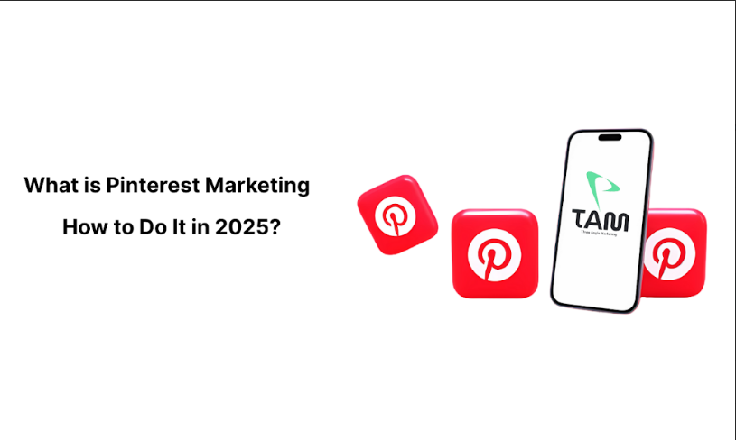
For any organization, it is always very important to look for ways and means of reaching potential customers. Pinterest Marketing is one of the most valuable platforms to focus on brand cooperation and consumer engagement. Having more than 450 million monthly active users around the world, Pinterest offers an opportunity to present products and services in an artistic presentation format.
In this guide, you will learn what Pinterest Marketing is and how you can use Pinterest Marketing for your business. Here you will learn everything about Pinterest Marketing and how you can excel at it in the year 2025.

What is Pinterest Marketing?
Pinterest marketing can be defined as the process of utilizing Pinterest, a web and app-based image sharing service, in marketing products, services, or brands. It capitalizes on the Pinterest functions to attract audience attention and generate traffic. This platform makes it beneficial for corporate businesses that intend to brand, generate leads, and boost sales.
Compared to traditional social networks, Pinterest is more suitable for inspiring the younger generation. Therefore, it is good for sectors such as fashion, design, beauty, and food. Currently, Pinterest Marketing has been improving with the ever-growing technology and changing users, and by 2025, it will be even better.

Key Components of Pinterest Marketing:
There are many components of Pinterest Marketing that make it more special and unique. Through the proper understanding of these components, you can easily learn without the working model of Pinterest Marketing:
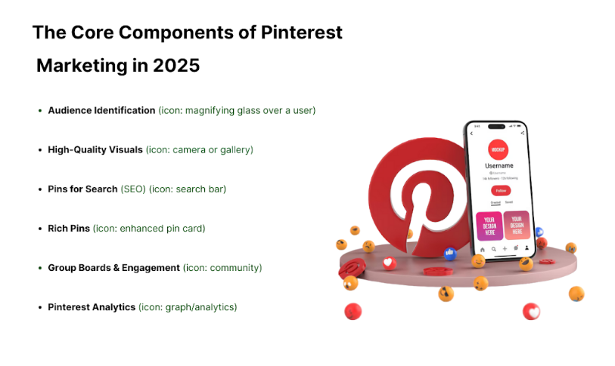

1. Audience Identification:
To market on Pinterest, it is essential that you first take the time to identify the target audience. Find out what they like, their age, gender, and the way they act on the internet so that you can develop content that can impress them. With the help of tools available in Pinterest, it is possible to explore what kind of content your targeted audience is interested in and how they interact with pins. In 2025 and beyond, these tools should provide even more specific information, which gives marketers the ability to put their plans into practice using exquisite accuracy.

2. High-Quality Visual Content:
Pinterest is a visual platform par excellence where members post photos mainly, and sometimes videos. So, make sure you use images of high quality in terms of resolution, the aesthetic appeal should be good, and appropriately chosen for the intended audience. Among them, infographics, step-by-step guides, and images associated with a specific lifestyle are the most appropriate. So, with time, AR and 3D content may be incorporated, which can be useful to attract users’ attention and diversify the platform.

3. Pins for Search:
When you are using Pinterest, you must optimize it for search engines. Being strategic in the selection and application of relevant keywords on the parties' pin-titles, pin-descriptions, and even the hashtags employed will go a long way in increasing the visibility of your pins. Some of the trends that the algorithm may place even more emphasis on in 2025 will be keyword optimization. Therefore, you need to remain updated on current trends about Pinterest in terms of SEO.

4. Rich Pins:
Rich Pins add more details to a pin and display them on the main pin itself. There are various forms of pins; for instance, there is a Product pin and a recipe pin, as well as an article pin. Rich Pins are already available on Pinterest and may extend their offering by the introduction of new types by 2025. That means that to unlock and fully utilize this particular feature, your website must be linked to Pinterest.

5. Pinterest Groups:
To begin to use Pinterest for professional engagement, you should become active in group boards and comment on the pins. Useful relationships within these communities will help with visibility and credibility. These communities will become more interactive by 2025 and beyond. This will ultimately open up for great potential of interactivity.

6. Pinterest Analytics:
Check your results using Pinterest Analytics for optimizing your Pinterest marketing results. Monitor such factors as the number of impressions, interactions, and CTR to evaluate the efficacy of the chosen approach. Again, more significant advancements are anticipated to be made in the use of analytics tools by 2025, such that apart from offering analytical data for navigation, the tools are likely to offer deeper analytical information as well as predictive analytical information, so that you can try to change.

Pinterest Ad Specs and Placement Types
Let’s talk about Pinterest Ad Spaces and Placement Types for a deeper understanding of this platform:
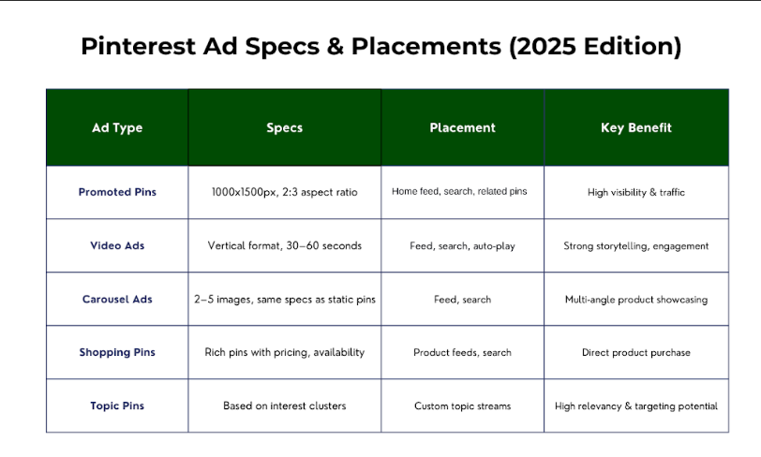

1. Ad Specs
It is important to understand Pinterest ad specifications for the creation of ads. Perhaps, these specifications will change with time by 2025, but the fundamentals will always be crucial.
- Image Size: Use high-quality images with a 2:3 aspect ratio. Although the given specifications might evolve now and in the future, high resolution of visuals will remain decisive.
- Video Length: Keep videos between 30 to 60 seconds. Perhaps, with the development of new technologies, it will be possible to use interactive or even immersive formats for videos.
- Call-to-Action (CTA): Ensure that the CTAs are obvious and persuasive so that they convey the desired user engagement. By 2025, it might be possible that there are different CTA options based on specific user actions,

2. Placement Types
There are several available ad placements on Pinterest, and each of them has its own goal. These placements may grow by 2025, so to be informed on the available opportunities, it is crucial to know the existing ones.
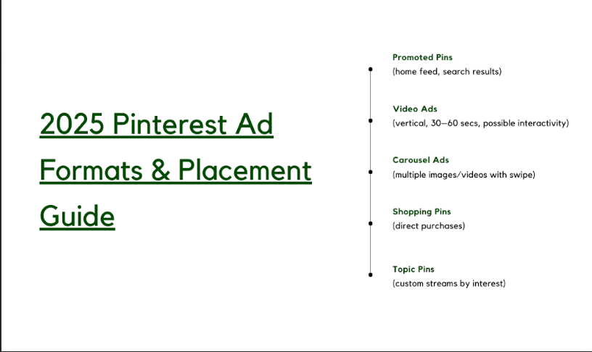
- Promotion Pins: Home feed, search results, and related pins. They are effective in the promotion of the brand, in addition to being useful in traffic generation.
- Video ad: The use of vertical video advertisement is effective in reaching out to users. Interactive video ads may further enhance the innovative approaches to attracting people’s attention by 2025.
- Carousel Ads: Marketing that is placed in such a way that it offers more than one picture or video is referred to as carousel ads. Such a format enables someone to present different facets of a given product or service that he or she has to offer. Subsequent variations may consist of the integration of games and other fanciful features.
- Shopping Ads: It will help the users to buy products from the page. Perhaps, such ads can provide easier and even seamless experiences.
- Topic Pins: It presents topic streams associated with particular topics of interest to the user. By 2025, such development might mean that Pinterest will provide specific subject-oriented streams to provide a targeted purchase channel for reaching out to specific consumer segments.

Why is it Crucial for Your Business To Use Pinterest Marketing?

In today’s world, the problem of differentiation is highly important. The following are some convincing factors why you should include Pinterest marketing in your business:
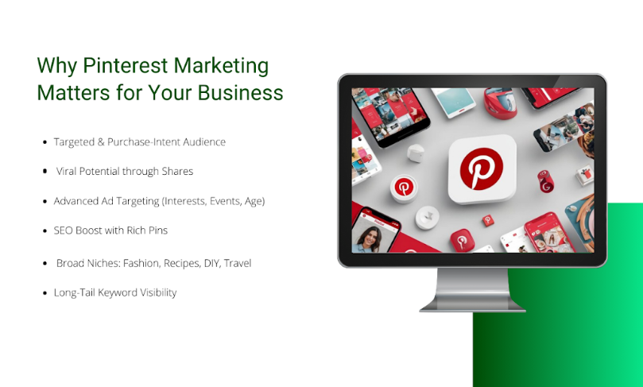

Targeted Audience:
All users of the platform are aware of the products that they want to purchase, although they are not ready to do so immediately. They are on the lookout for inspiration and ideas. Therefore, they belong to a highly receptive category with good intentions and are intended to interact with your brand.

Viral exposure:
Pins can become viral. For every pin, you have millions of users as your potential customers to make your brand well recognized and active.

Advertising Opportunities:
Pinterest is a very relevant platform for advertisements, and it has state-of-the-art advertising opportunities that can be targeted according to age, interest, life event, etc. This accuracy enables you to achieve the intended target in conveying your message.

SEO Advantages of Using Pins:
There is more traffic that can be generated to your website through the use of pins. One sure way of ensuring the pins are very well displayed when a person is searching for them in the search engines is to optimize the pins with keywords and rich pin descriptions.

Diverse Product Categories:
Pinterest has a broad variety of content, including recipes, home improvement, travel, fashion, etc. So, the organizations in different fields can develop amusing content.

Long-Tailed Keywords:
Pinterest is favorable for the use of long-tail keywords. The first specific phrases ensure that your content targets specific audiences, while the second set of phrases enhances the visibility of your content.

How to Create a Pinterest Strategy in 2025?
Below are the steps that you can follow to create a perfect Pinterest marketing plan for 2025:

1. Set Clear Goals:
So, before going to Pinterest, it is crucial to determine the goals for it. These goals may be to generate higher visitor traffic to the site, enhance brand reputation, acquire leads, or boost sales. Common goals are for winning the war to guide strategy and measure what was achieved.

2. Understand Your Audience:
Knowing your audience is crucial. Before proceeding with your campaign, gather information on the target groups in terms of their age and gender, interests, and activities of your audience on this platform. To get to grips with the features and the complexity of the chosen topic, it is useful to create personas that will help in the understanding of the target audience's needs and preferences. This insight will assist you in generating appropriate, compelling material.

3. Optimize Your Profile:
Pinterest is your business’s away-from-home and, subsequently, it acts as your business platform. It is usually essential to check if it aligns more with the existing brand image of your organization. Make sure you create a distinguishing logo, provide an interesting and engaging biography, and choose an appropriate background image of your picture. This can be an authoritative link to your website to increase traffic to your website.

4. Create a Content Plan:
Create a content calendar that will help you in scheduling the kind of pins you would like to share. At all times, consider trends, seasons, and occurrences that may be relevant to the content you will be creating. Continuity plays an important role in keeping the people engaged and constantly checking what the page posts.

5. Focus on Visual Appeal:
Pinterest is all about visuals. Use high-quality photos and graphics, as this reflects the company’s image to the public. Some tips on creating the best pins include creating stunning pins using applications such as Canva or Adobe Spark. Make sure your visuals fit the aesthetic of your brand.

6. Utilize Rich Pins:
In comparison to Standard Pins, you can provide more information about an idea in Rich Pins because the extra information is placed on the same Pin. They are especially suitable in business because they contain information such as the price of the product, the quantity available, among other important details regarding the product. To add value to the content, use the feature, Rich Pins.

7. Craft Compelling Pin Descriptions:
Descriptions are crucial for SEO. So, make sure to add keywords naturally in the descriptions of the given pins. Ensure that they are brief and at the same time informative, as well as having a proper call-to-action (CTA) that can direct the user to the next step.

8. Leverage Pinterest Analytics:
Pinterest has tools that come in handy in analyzing the performance of your published content. It will be advisable to review these regularly to see what measures are effective or ineffective. This will enable you to make better decisions and increase your effectiveness in reaching your goals.

9. Engage with the Community:
Engagement is a two-way street. Responding to comments, joining group boards, and influencing other personalities. Relationship building is essential when it comes to the visibility of your account as well as its credibility among Pinterest users.

10. Experiment with Pinterest Ads:
You can experiment with Multichannel marketing for successful advertisement with a limited budget for experimenting with the ad formats and targeting possibilities. It portrays the importance of tracking the outcomes and making the necessary revisions to current strategies.

11. Monitor Competitors
Analyze your competitors’ Pinterest strategies. Perceive where they are succeeding and where they are lacking. Take these findings seriously and apply them as a way of improving your strategies in the field.

12. Encourage User-Generated Content
Promote the act of your customers to prepare and post different pins that capture and exhibit your merchandise. Just like customer feedback, make sure user-generated content is real, genuine, and effective in increasing the credibility of a particular brand.

13. Focus on Long-Term Content
Concentrates on the content that will always be in demand regardless of the period when it was created. Develop pins that are useful and of value to the audience, even in the long run. This way, you can ensure that your content can generate traffic even after it would have been posted some time back.

15. Continuously Optimize
The analysis of Pinterest marketing also points out that the process of optimization is a continuing one. Monitor your posts, your interactions, and the entire plan regularly. Expect changes in the population’s use of information and the online environment, and be prepared to adapt to them.

Future Trends in Pinterest Marketing:
Several trends should be expected in Pinterest Marketing by the year 2025. Let’s discuss these trends to achieve better clarity about the future of Pinterest Marketing:

- Prominent role of AI: AI’s application is going to be dominant in the field of content generation, targeting, and analysis. Expect to see more custom as well as targeted marketing stimuli.
- Multimedia Upgradation: Augmented reality and 3D material/asset will be much more favorable and provide new ways to interact with users.
- Better Analytics: This offers the opportunity to derive even better insights, and predictive analysis functions will be more enhanced.
- More Interaction: As the groups evolve, more interaction will be witnessed between Pinterest communities.
- E-commerce integration: There will be much smoother buying processes as the trend moves on, propelling Pinterest as an even stronger e-commerce tool.

Tools for Pinterest Marketing: Paid & Free
When it comes to Pinterest marketing by the year 2025, the choice of tools is essential. Below is a list of both Pro and freeware that will complement your approach:
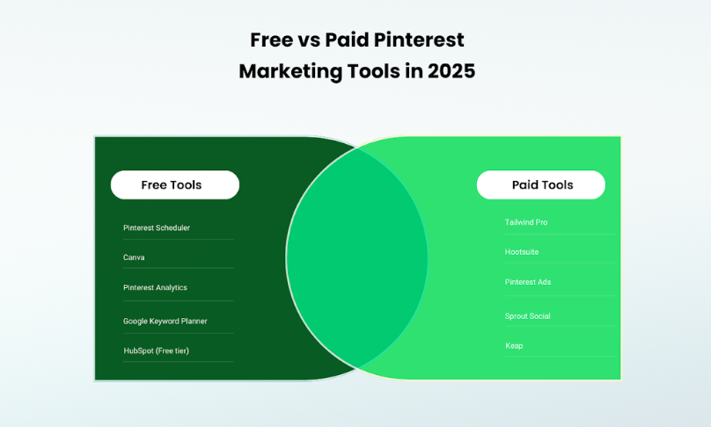

Free Tools:

Pinterest Scheduler:
This allows having a consistent posting on Pinterest, and there is no need to spend time daily on it. It also includes analytics that could help you monitor your progress in a certain level of social media usage.

Canva:
This is one of the simple graphic design tools that will enable you to create more professional pictures and images for your pins. It has several templates, and this makes it easy to create beautiful content.

Pinterest Analytics:
It is another feature of Pinterest that helps the user to receive information about the profiles that they have used for analysis and engagement rate, and the audience demographics. Let me use it to enhance my plan from the quantitative aspect, given that the advanced tools help to gather pertinent information.

Google Keyword Planner:
Google Keyword Planner is useful even though it is not specific to Pinterest, and also helps with the identification of keywords for the URLs to be used in SEO. I have also included these terms in the title of each pin as well as in the description to increase the chance of being viewed.

HubSpot:
HubSpot has free resources when it comes to inviting, content creation, scheduling, and analysis of Pinterest marketing. HubSpot marketing tools are complementary to the software because it is designed to connect with other HubSpot features.

Paid Tools:

Tailwind Pro:
The paid version comes with more enhanced features such as Smart Scheduling, Analytics, and the Collaboration Page. It is highly suitable for businesses interested in expanding their Pinterest marketing strategy.

Hootsuite:
This social media management tool comes with the features of the Pinterest app integration, where you can schedule your pins and track engagement of the account or multiple accounts at once.

Pinterest Ads:
This is an Organic way of advertising on Pinterest. It is Pinterest’s very own advertising platform used to create and manage the ad campaign. It has effective targeting mechanisms and even collects data to take care of its advertising efficiency.

Sprout Social:
It also has Pinterest functionalities as it is a social media management platform. It includes time-management features, interactivity, analytics, and reporting. This tool is useful for different marketing personnel.

Keap:
Keap is an innovative product that enables website owners to add marketing automation tools, such as Pinterest. It makes it easier to bring together item marketing and improve lead generation.

Conclusion:
Pinterest Marketing is beyond doubt one of the most effective means of reaching audiences through the use of inspiration. To successfully promote your brand, you should always consider your audience, work on the quality of content, and use all the features offered by Pinterest for advertising. However, with every advancement in adopting technology in the market, new approaches and tools for Pinterest Marketing also emerge. It is therefore necessary for you to become knowledgeable about the changes that you need to make in the platform to help you succeed in the year 2025 and other subsequent years.
In case you are still confused about how to get started with Pinterest, feel free to contact the Three Angle Marketing experts. Our team is ready to offer you full support by creating result-oriented strategies.

